# Workshop: ASP.NET and Databases

Workshop for the ["ASP.NET Core Fundamentals" course @ SoftUni](https://softuni.bg/trainings/3853/asp-net-fundamentals-september-2022)

In this workshop we will create a **simple ForumApp, similar to the ShoppingListApp** from the slides from the previous session. Our app will have a page for **displaying all added forum posts** with their content and with [**Edit**] and [**Delete**] buttons and an [**Add Post**] button. It also should display a form for adding a post and editing a post and it should ask for a confirmation when deleting a post. It will look like this:

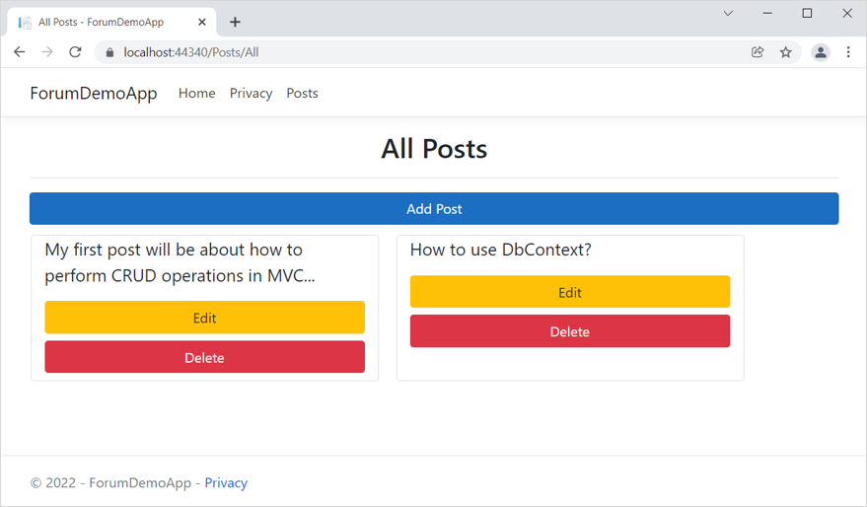

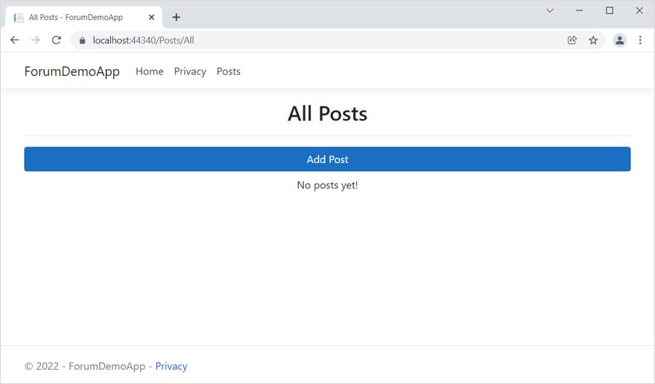

## Define Entities

We should start with creating the data model, which we will need for our database. We will have only one data model class – **Post**.

Create the **Post** class in the "**Data**" folder of the project. It's a good practice for the data model classes to be in a separate folder from the **ForumDbContext** class – the "**Entities folder**".

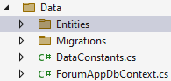

The **Post** class should have the following properties:

* **Id** – an unique **integer**, primary key
* **Title** – a **string** with min length **10** and max length **50** (required)
* **Content** – a **string** with min length **30** and max length **1500** (required)

Create the **Post** class in the "**Entities**" folder with its **properties without restrictions:**

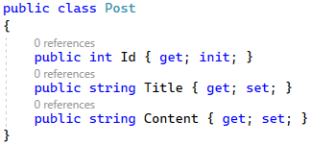

Note that we use **init** setters only for **properties**, which **won't be changed after the initialization**. For example, the **Id** property will always be the same.

Now, add the **[Required]** **attribute** to those **properties**, which **must have a value**.

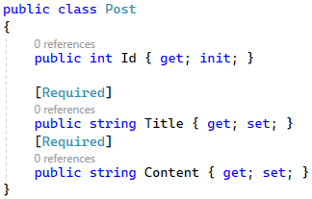

Note that you don't need to set the **Id** property as a **primary** **key** in any way – this is done **by** **default** in **EF Core** because of the "**Id**" property name.

Now we should **restrict the properties**. The only restriction we will set is for the **max** **length**, as the database doesn't care about other validations. **Min length**, **range** and other **restrictions** are added to **model classes**.

The **properties**, which should have a **max length,** are Title and Content.

It is a good idea to create a **separate class with constants** for the max length values. In the "Data" **folder**, create the DataConstants **class**:

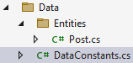

In this class, create a **Post** class for the constants, connected to a post entity, and the constants themselves:

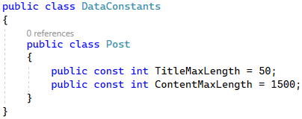

Add the needed namespace to use the constant class in the **Post** class:



Use the **constants** in the [MaxLength] **attribute** to **set the max length** like this:

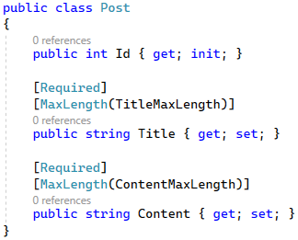

Now the entity class is ready.

## Define the DbContext

Now let's add our **ForumAppDbContext** class in the "**Data**" folder.

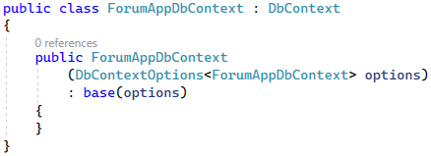

We should use the **Migrate()** method in the constructor in order for the changes to be applied to tbe database directly.

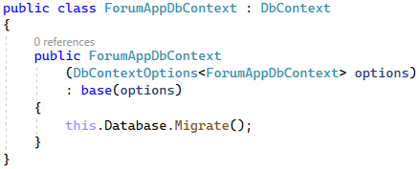

Create the **DbSet** properties for the table in the database:



|  |  |
| --- | --- |
|  | EF Core uses a "cascade" **delete** by default when **removing an entity**. This means that if a record in the **parent table is deleted**, then the **corresponding records** in the child table **will automatically be deleted**. To prevent this from happening, it's a good practice to set the **delete behavior** to "restrict", so that an entity, which has **connections** to other entities in the database, **won't be deleted.** |

In our case, there's no entity that has connections to other entities If there was such entity, the **OnModelCreating(ModelBuilder builer)** method in the **ForumAppDbContext** class should be overridden:

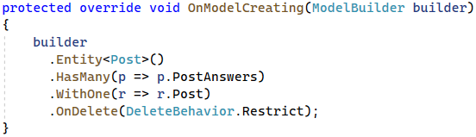

At the end, invoke the **base** OnModelCreating() **method**:

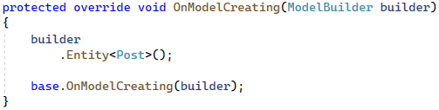

Now our **database structure** is ready. If you migrate it now, however, it will be **created with empty tables**. For this reason, let's see how to **seed some data** **to fill in the database tables**.

## Seed the Database

Now, we want to **populate the database** with an **initial set of data**. This will include **three posts.**

First, create properties for the above objects in the **ForumAppDbContext** class:

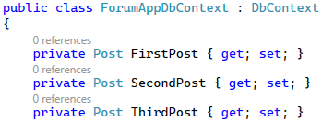

The, we will use a **separate** **method** to **add data to these objects**, which will be **added** to the **corresponding** **database** **table** in the **OnModelCreating(ModelBuilder builder)** **method**. Add the following lines of code to the method, before invoking the base one:

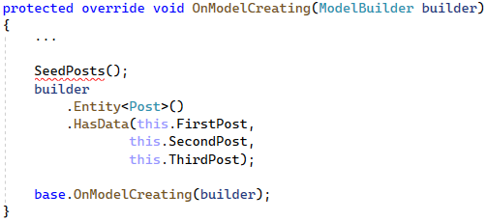

|  |  |
| --- | --- |
|  | When **invoking more that one seeding method**, it is important that the **seeding methods are invoked in the correct order**, as they **depend** on each other. |

Let's implement the **SeedPosts()** class, which will create the posts for the database.

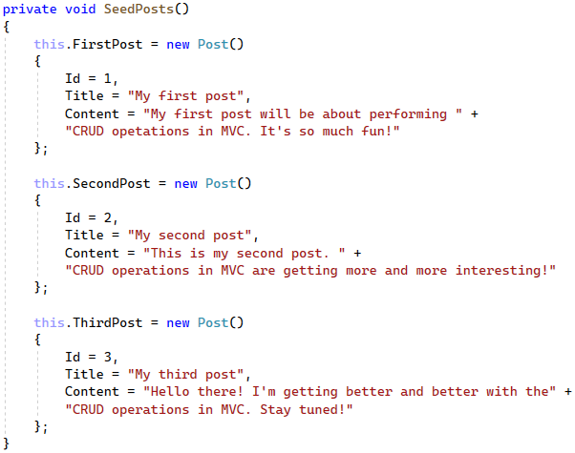

Now we have a db context with **seeded data** and our **database is ready to be migrated**.

## Create a Migration

We will now **create a migration** to the database.

To do that, first we need to add the connection string in the "**appsettings.json"** file:

 and set the **DbContext** to use SQL with the connection string in the **Program** class.

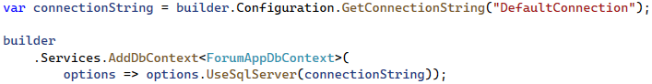

Next, open the Package Manager Console from [Tools] 🡪 [NuGet Package Manager] 🡪 [Package Manager Console] to write **commands** for **managing migrations**:

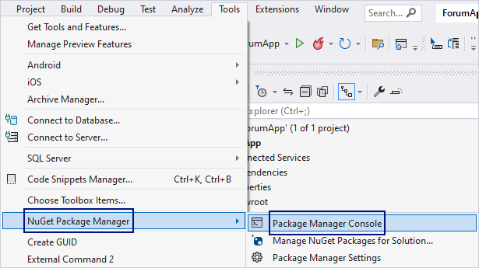

In the **console**, write a command for **adding a migration** to the "Data/Migrations" **folder** with a given **name** and **press** [Enter] to **execute it**. The **result** should be the following:

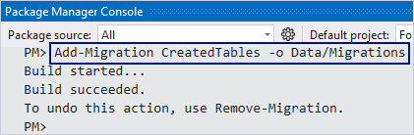

Now you should have a new migration in the "**Migrations**" folder:

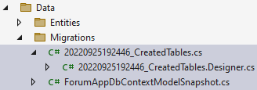 🡪

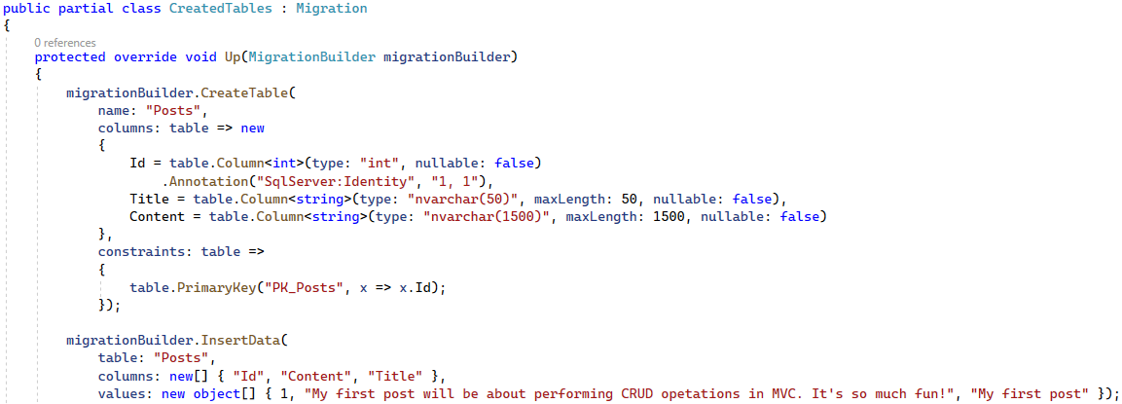

**Examine the tables** and its **restrictions** in the **new migration** – if something is wrong, **delete the migration** with the "Remove-Migration" **command** or **delete the migration file**. Don't forget that you should also **delete the database** from SQL Server Management Studio, or errors will appear.

Now **run the app** in the browser – there should not be **any errors**. Then, look at the **newly-created database** in SQL Server Management Studio and **examine the table** – it should be **present** and have the **right restrictions** and **relationships**:

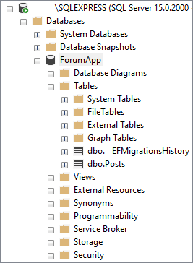

Look at the "**Posts**" table – it should contain the three posts that we seeded:

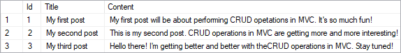

## CRUD operations

After we have populated our database, we can start executing CRUD operations.

### Reading Data

First, we need to create a new **PostsController** in the "**Controllers**" folder".



Let's inject the **ForumAppDbContext** through the constructor and assign it to a variable to use it:

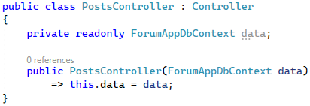

Our next step should be creating the **PostViewModel** in the **"Models"** folder.

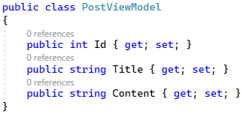

After the **PostViewModel** is created, we'll go back to the **ProductsController** and add a new method **All()**. The task of this method is to extract the products from the database to a model collection, which will be passed to a view.

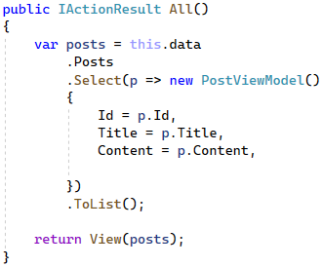

Now we should create the "**All.csthml"** view file. We will create all of the views in a new folder, called "**Posts**", which will be located in the "**Views"** folder.

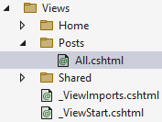

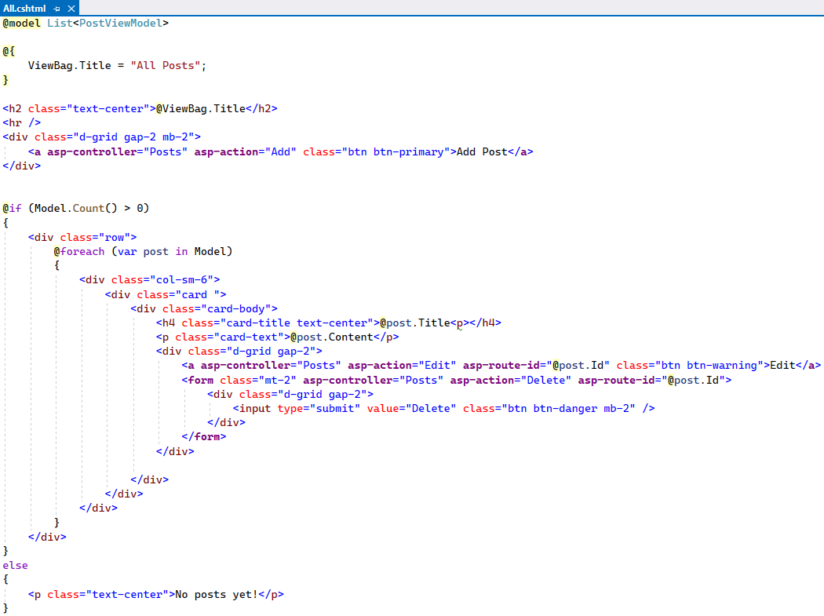

As this file contains more code, you can copy it from here:

|  |
| --- |
| @model List<PostViewModel>  @{  ViewBag.Title = "All Posts";  }  <h2 class="text-center">@ViewBag.Title</h2>  <hr />  <div class="d-grid gap-2 mb-2">  <**a** **asp-controller**="Posts" **asp-action**="Add" class="btn btn-primary">Add Post</**a**>  </div>  @if (Model.Count() > 0)  {  <div class="row">  @foreach (var post in Model)  {  <div class="col-sm-6">  <div class="card ">  <div class="card-body">  <h4 class="card-title text-center">@post.Title<p></h4>  <p class="card-text">@post.Content</p>  <div class="d-grid gap-2">  <**a** **asp-controller**="Posts" **asp-action**="Edit" **asp-route-id**="@post.Id" class="btn btn-warning">Edit</**a**>  <**form** class="mt-2" **asp-controller**="Posts" **asp-action**="Delete" **asp-route-id**="@post.Id">  <div class="d-grid gap-2">  <input type="submit" value="Delete" class="btn btn-danger mb-2" />  </div>  </**form**>  </div>    </div>  </div>  </div>  }  </div>  }  else  {  <p class="text-center">No posts yet!</p>  } |

Now **run the app** in the browser – there should not be **any errors** and the **Home page** should be displayed:

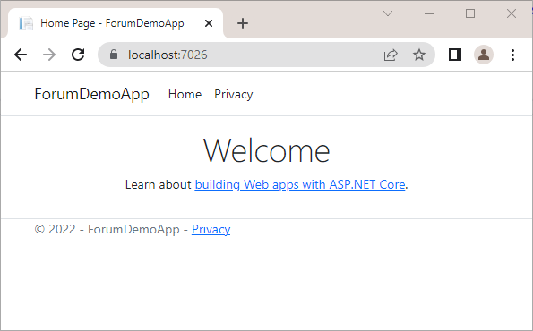

You can access the page that contains the collection with the posts on "/Posts/All". For our convenience, we will add a link to the navigation pane to access the Posts page. The navigation pane should look like this:

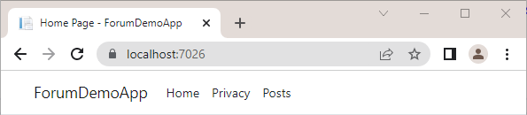

To **add links**, go the _Layout.cshtml **partial view** in the "/Views/Shared" **folder**, as this view is responsible for the **common design** of all pages. Add the following lines:

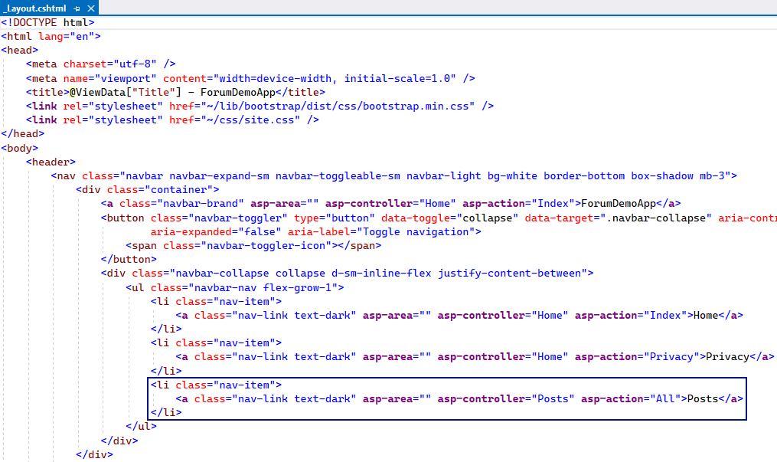

If we follow the newly added link, we should be able to see the Posts page and it should look like this:

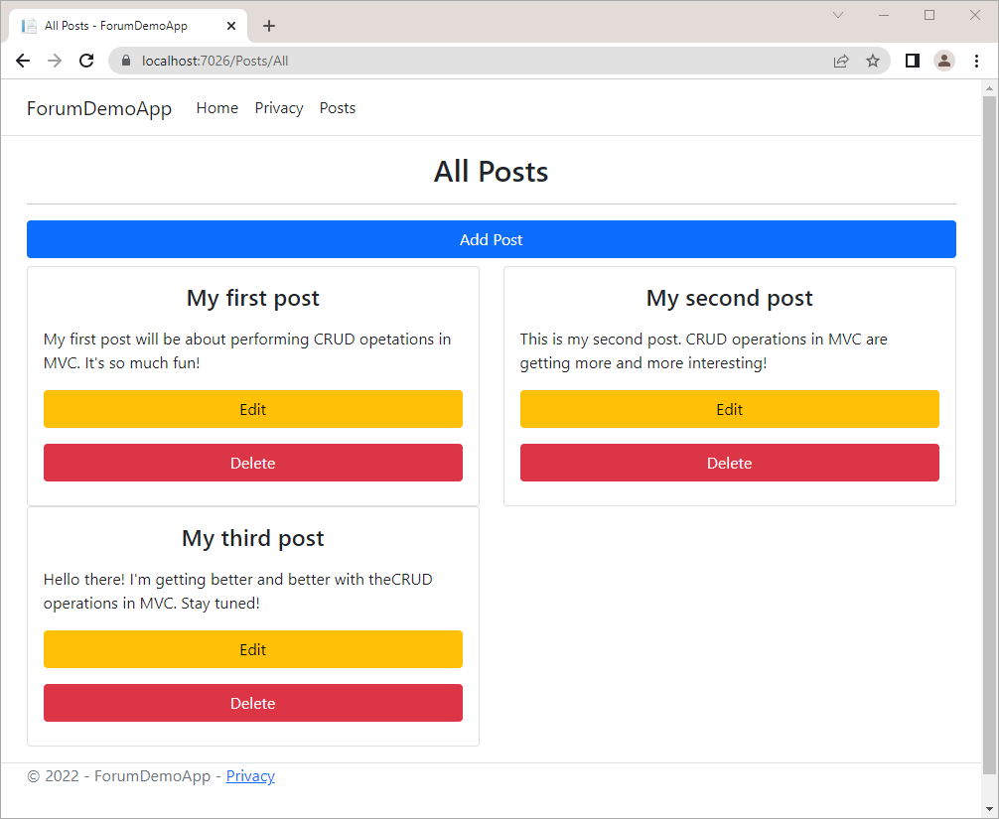

### Creating New Data

The next step in creating the **ForumApp** is adding the "**Add Post**" page. It will display a **form** for **adding a post** and it will look like this:

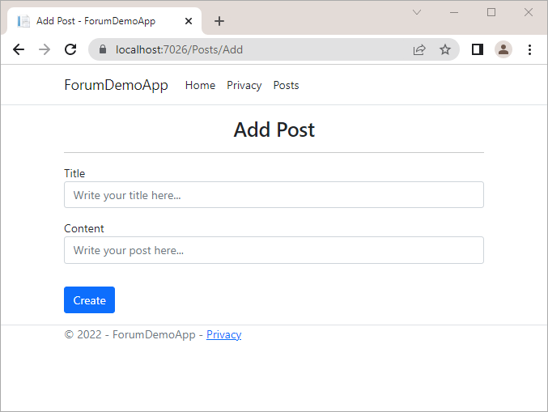

First, we need to create the **PostViewModel** in the **"Models"** folder. We will add validation attributes to the model property. The **[Required]** attribute will check if the model property holds any value and the **[StringLength]** will check the length of the string that is held as a value.

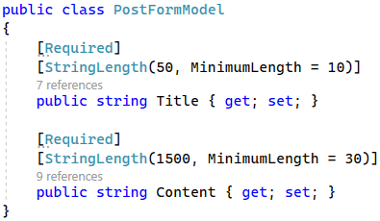

After we have created the **PostViewModel** we should go to the **PostsController** and implement the **Add()** method. This method will create a new **Post** object and then add it to the **DbSet**.

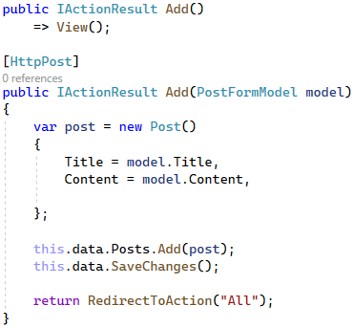

Finally, we have to add a new "**Add.cshtml"** in the **"/Views/Posts"** folder for the **"Add Product"** Page view:

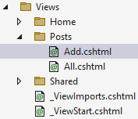

The file should look like this:

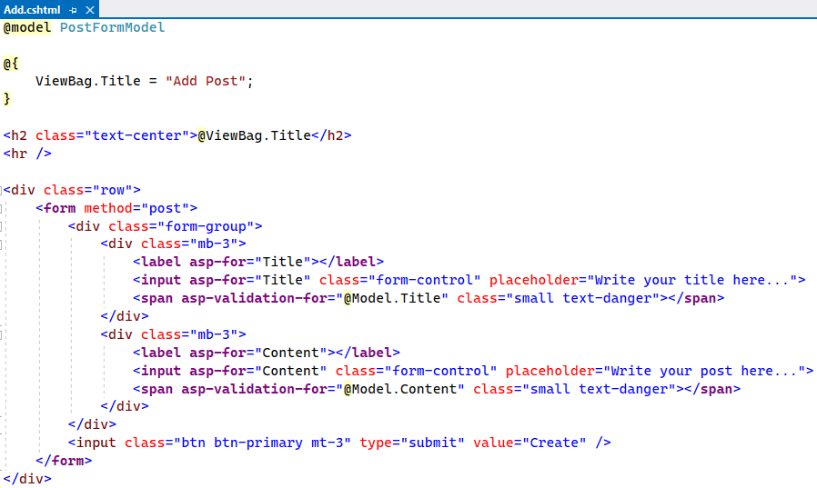

You can copy the code from here:

|  |
| --- |
| @model PostFormModel  @{  ViewBag.Title = "Add Post";  }  <h2 class="text-center">@ViewBag.Title</h2>  <hr />  <div class="row">  <**form** method="post">  <div class="form-group">  <div class="mb-3">  <**label** **asp-for**="Title"></**label**>  <**input** **asp-for**="Title" class="form-control" placeholder="Write your title here...">  <**span** **asp-validation-for**="@Model.Title" class="small text-danger"></**span**>  </div>  <div class="mb-3">  <**label** **asp-for**="Content"></**label**>  <**input** **asp-for**="Content" class="form-control" placeholder="Write your post here...">  <**span** **asp-validation-for**="@Model.Content" class="small text-danger"></**span**>  </div>  </div>  <input class="btn btn-primary mt-3" type="submit" value="Create" />  </**form**>  </div> |

Let's not forget to add the following code in the **Add.cshtml** file in order for the app to be able to validate the input data.

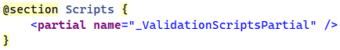

Now we can run the app in the browser and add a new post. After adding the new post, the All Posts page should look like this:

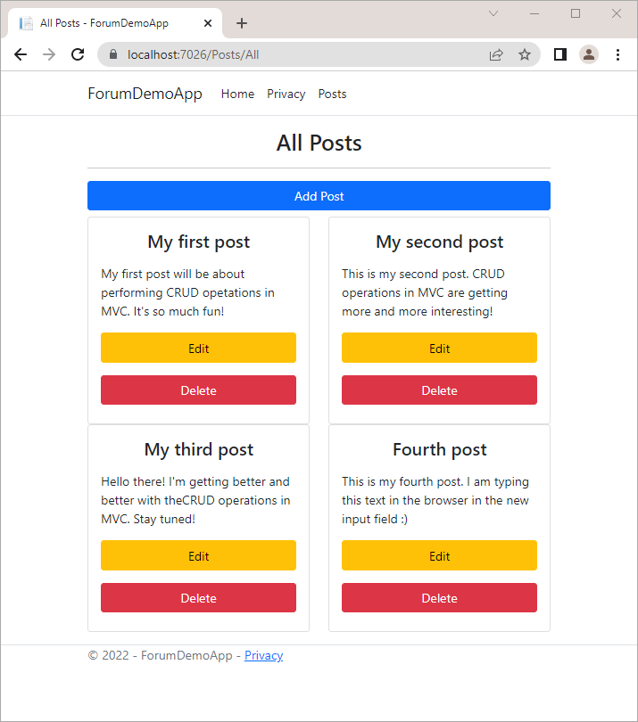

Now let's check the database in SQL Server Management Studio and **examine the "Posts" table** – it should **contain the new post that we just created:**

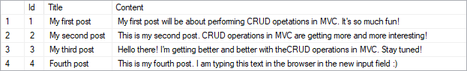

We can check if the app validates the title and content, which we want to add for our post. If their length doesn't meet the requirements, the app should look like this: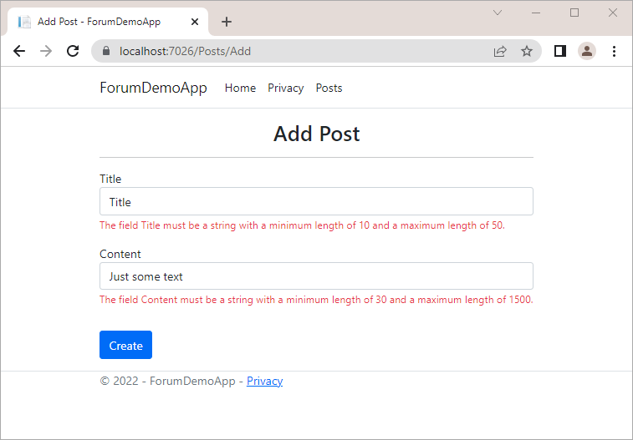

### Updating Existing Data

The next step in creating the **ForumApp** is adding the "**Edit Post**" page. It will display a **form** for **editing a post** and it will look like this:

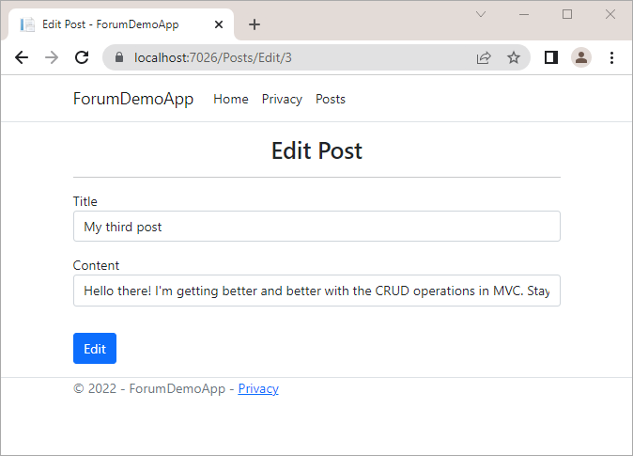

Now let's edit one of the posts that we already have in the collection. First, we need to modify the **ProductsController** and add an **Edit()** method, which will pass a **Post** model to the view and find and update the post in the database.

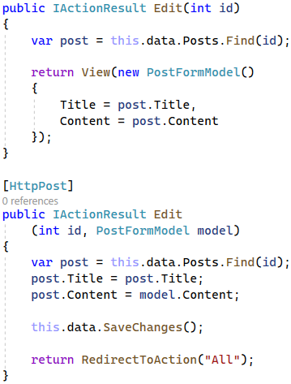

Our next step is to add a new "**Edit.cshtml"** file to display the form for editing posts.

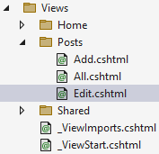

Let's not forget that we have to add validation for the length of the post's title and content.

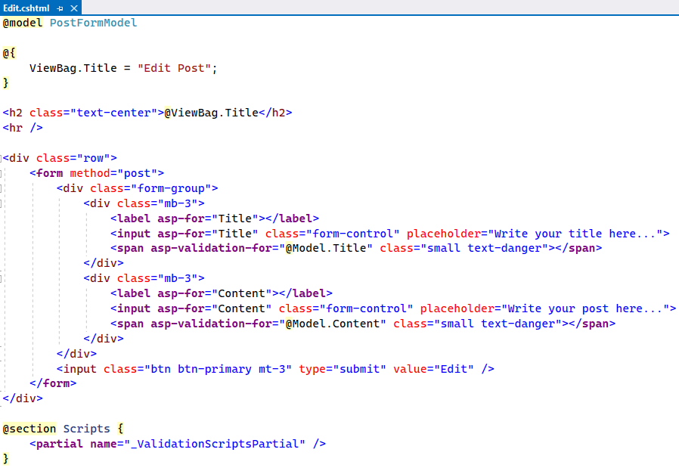

You can copy the code from here:

|  |
| --- |
| @model PostFormModel  @{  ViewBag.Title = "Edit Post";  }  <h2 class="text-center">@ViewBag.Title</h2>  <hr />  <div class="row">  <**form** method="post">  <div class="form-group">  <div class="mb-3">  <**label** **asp-for**="Title"></**label**>  <**input** **asp-for**="Title" class="form-control" placeholder="Write your title here...">  <**span** **asp-validation-for**="@Model.Title" class="small text-danger"></**span**>  </div>  <div class="mb-3">  <**label** **asp-for**="Content"></**label**>  <**input** **asp-for**="Content" class="form-control" placeholder="Write your post here...">  <**span** **asp-validation-for**="@Model.Content" class="small text-danger"></**span**>  </div>  </div>  <input class="btn btn-primary mt-3" type="submit" value="Edit" />  </**form**>  </div>  @section Scripts {  <**partial** **name**="_ValidationScriptsPartial" />  } |

Now run the app in the browser and test it. You can also examine the "**Posts**" table in the SQL Server Management Studio.

### Deleting Existing Data

The final step in creating our **ForumApp** is adding the functionality to perform a **Delete** operation. This means that when we click on the [**Delete]** button of a post, it has to send a **POST** reques to the controller. It's a good practice to add a client-side delete confirmation, so we will do that, too.

In order to do that, we need to add a new method **Delete()** in the **ProductsController**:

Next, we need to go to the "**All.cshtml**" file and add the following code:

The **onclick attribute** ofthe **[Delete]** button enables the JavaScript **confirm()** function, which displays the confirmation dialog to the user. If the [**Cancel**] button is clicked, the **confirm()** function returns **false** and nothing happens. If the [**OK**] button is clicked, the form is submitted and the post is deleted from the database.

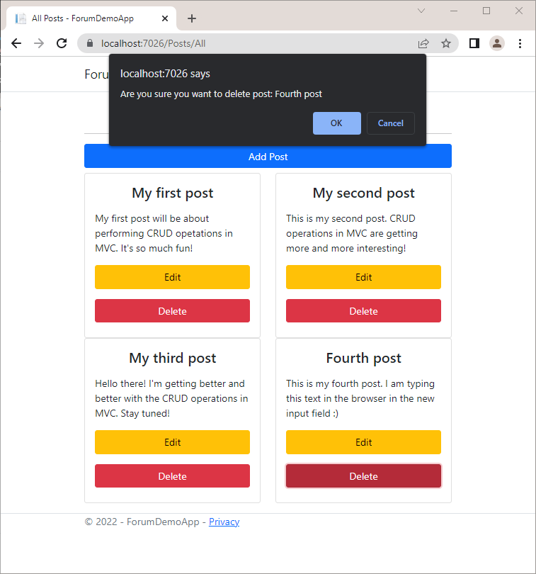

Now run the app in the browser and test it. You can also examine the "**Posts**" table in the SQL Server Management Studio.